문제해결기법(13967005)

202135592 한웅재

소프트웨어

제출일: 2021. 10. 2

Q1. Exact Match p.35

#define _CRT_SECURE_NO_WARNINGS// or scanf_s

#include <stdio.h>

#include <math.h>

#include <stdlib.h>

#include <string.h>

#include <time.h>

#include <ctype.h>

#define NUM_TEST_SET 5

int search_string(char *string,char *search);

int main() {

char test_str[NUM_TEST_SET][1024] = {"Every day for the past month, Emal Ahmadi's 7-year-old daughter Hada has asked him the same thing: ""Where is my sister ?"""

,"She misses playing with her younger sister Malika, he says. She cries a lot, wondering when she is coming home."

,"Malika died in a US drone strike in the courtyard of their family home in Afghanistan's capital on August 29, along with ten other relatives, six of them children."

,"Speaking outside of the courtroom on Thursday, Sarkozy's lawyer Thierry Herzog told French media that he would be launching an appeal."

,"Lambert said he told Sarkozy about the memo and indicated to him the necessity to cut campaign spending, while Sarkozy maintained that he had no knowledge of the overspending."};

char test_search_str[NUM_TEST_SET][128] = {"the","She","in","the courtroom on Thursday","and indicated to him"};//2, 2, 3, 1, 1

for (int i = 0; i < NUM_TEST_SET; i++) {

char* str = test_str[i];

char* search_str = test_search_str[i];

int num_matches = search_string(str,search_str);

printf("\n// --- EXPERIMENT(%d) --- //\n",i+1);

printf("String : %s\n",str);

printf("Search : %s\n",search_str);

printf("Num Matches : %d\n",num_matches);

}

return 0;

}

int search_string(char* string, char* search){

int match_num = 0;

for (int i = 0; i < strlen(string); i++) {

if (string[i]==search[0]) {

int match = 0;

for (int k = 0;k<strlen(search);k++) {

if (string[i + k] == search[k]) {

match++;

}

}

if (match == strlen(search)) {

match_num++;

}

}

}

return match_num;

Q2. Partial Match p.35

#define _CRT_SECURE_NO_WARNINGS// or scanf_s

#include <stdio.h>

#include <math.h>

#include <stdlib.h>

#include <string.h>

#include <time.h>

#include <ctype.h>

#define NUM_TEST_SET 5

void Divide_search_string(char *search_str,char *first,char *second);

int search_string(char *string,char *search);

int partial_match_count(char* search_str, char* first, char* second);

int main() {

char test_str[NUM_TEST_SET][1024] = {"Every Ever Ever sdgdsfg y"

,"My name is hong gil dong. My brother is hong je dong. My sister is hong gilja, and her friend is hongdong."

,"i sdfsd n i n i in"

,"Speaking outside of the courtroom on Thursday, Sarkozy's lawyer Thierry Herzog told French media that he would be launching an appeal."

,"Lambert said he told Sarkozy about the memo and indicated to him the necessity to cut campaign spending, while Sarkozy maintained that he had no knowledge of the overspending."};

char test_search_str[NUM_TEST_SET][128] = {"Every","hong*dong","i*n","the courtroom* on Thursday","and indicat*ed to him"};//2, 2, 3, 1, 1

char first[NUM_TEST_SET][128] = { {" "}, {" "}, {" "}, {" "}, {" "}};

char second[NUM_TEST_SET][128] = { {" "}, {" "}, {" "}, {" "}, {" "}};

for (int i = 0; i < NUM_TEST_SET; i++) {

char* str = test_str[i];

char* search_str = test_search_str[i];

char* first_s = first[i];

char* second_s = second[i];

printf("\n// --- EXPERIMENT(%d) --- //\n",i+1);

printf("String : %s\n",str);

Divide_search_string(search_str, first_s, second_s);

printf("Search-First : %s\n", first_s);

printf("Search-Second : %s\n", second_s);

int num_matches = partial_match_count(str, first_s, second_s);

printf("Num Matches : %d\n",num_matches);

}

return 0;

}

void Divide_search_string(char* search_str, char* first, char* second) {

int i = 0;

char *ptr = strtok(search_str, "*");

while (ptr!=NULL) {

if (i == 0) {

strcpy(first,ptr);

}

if (i == 1) {

strcpy(second, ptr);

}

i++;

ptr = strtok(NULL,"*");

}

printf("");

}

int partial_match_count(char* search_str, char* first, char* second) {

int match_count = 0;

int each_match = 0;

for (int i = 0; i < strlen(search_str);i++) {

//first str

if (search_str[i] == first[0]&& second[0]!= ' ') {

int match = 0;

for (int k = i; k < i + strlen(first); k++) {

if (search_str[k] == first[match]) {

match++;

}

}

if (match == strlen(first)) {//first is right

for (int j = i + strlen(first); j < strlen(search_str); j++) {//find second and the same first

each_match = 0;

//예외처리

if (search_str[j] == first[0]) {

int match_1 = 0;

for (int r = 0; r < strlen(first); r++) {

if (search_str[j+r] == first[match_1]) {

match_1++;

}

else {

match_1 = 0;

break;

}

}

if (match_1 == strlen(first)) {

break;//first 중복

}

}

//예외처리

//second str

if (search_str[j] == second[0]) {

int match_2 = 0;

for (int n = j; n < j + strlen(second); n++) {

if (search_str[n] == second[match_2]) {

match_2++;

}

else {

match_2 = 0;

break;

}

}

if (match_2 == strlen(second)) {

each_match++;

if (each_match == 1) {

match_count++;

}

}

}

}

}

}

else if (search_str[i] == first[0] && second[0] == ' ') {

int match = 0;

for (int k = i; k < i + strlen(first); k++) {

if (search_str[k] == first[match]) {

match++;

}

}

if (match == strlen(first)) {

match_count++;

}

}

}

return match_count;

}

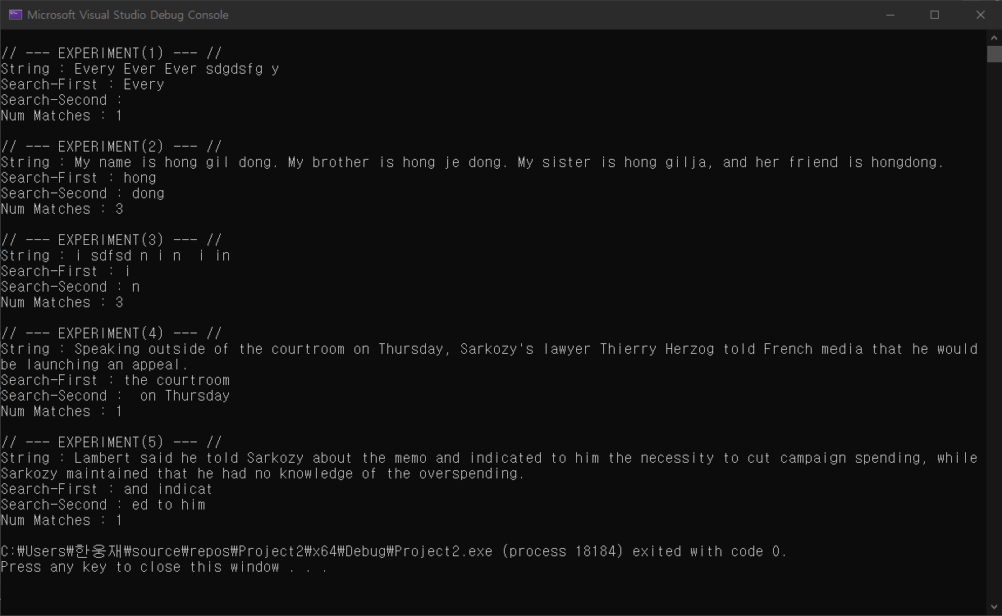

Q3. Index Search p.43

#define _CRT_SECURE_NO_WARNINGS// or scanf_s

#include <stdio.h>

#include <math.h>

#include <stdlib.h>

#include <string.h>

#include <time.h>

#include <ctype.h>

#define NUM_TEST_SET 3

struct DATASET {

char name[10];

int age;

char hobby[10];

}dataset[5] = { {"Kim",39,"Tennis"},

{"Ko",15,"Soccer"},

{"Lee",17,"Soccer"},

{"Choi",21,"Tennis"},

{"Park",10,"Tennis"}};

struct INDEX {

char key[10];

int index;

}index[5] = { {"Kim",0},

{"Ko",1},

{"Lee",2},

{"Choi",3},

{"Park",4}};

int Search_Index(char* search);

int main() {

char test_search_keys[NUM_TEST_SET][10] = {"Cha","Lee","Park"};

for (int i = 0; i < NUM_TEST_SET; i++) {

char* search_key = test_search_keys[i];

int index = Search_Index(search_key);

printf("\n _-_-_Experiment [%d]_-_-_ \n", i + 1);

printf("Key: %s\n", search_key);

if (index < 0) {

printf("THE KEY DOES NOT EXIST \n");

}

else {

printf("RESULT: INDEX[%d], NAME[%s], AGE[%d], HOBBY[%s] \n", index, dataset[index].name, dataset[index].age, dataset[index].hobby);

}

}

return 0;

}

int Search_Index(char* search) {

for (int i = 0; i < 5; i++) {

for (int k = 0; k < strlen(index[i].key); k++) {

if (index[i].key[0] == search[0]) {

int match_count = 0;

for (int r = 0; r < strlen(search); r++) {

if (index[i].key[r] == search[r]) {

match_count++;

}

if (match_count == strlen(index[i].key)) {

return i;

}

}

}

}

}

return -1;

